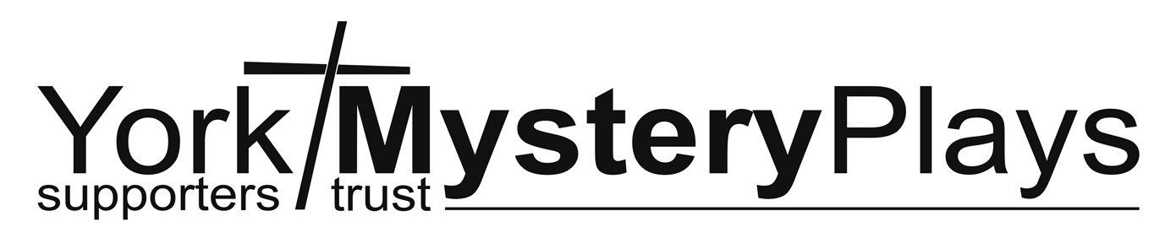

Health and Safety Policy

General statement of policy

York Mystery Plays Supporters Trust (YMPST) is working towards a comprehensive Health and Safety Policy and is bound to abide by the Health and Safety at Work Act. This lays down certain duties on all volunteers. The duties are to take care of their own safety and that of supporters and visitors and to co-operate with the the Trustees (normally the Committee) to enable YMPST to carry out its responsibilities.

In particular volunteers have a duty to:

- work safely, efficiently and without endangering the health and safety of themselves, their colleagues or any other person

- adhere to safety procedures laid down by YMPST from time to time, and conform to all instructions given by those with a responsibility for health and safety

- report all accidents, near miss-occurrences and hazardous situations to a Trustee for recording in the Accident book; the Trustee should ensure the incident is reported to the next Committee meeting

- meet their other statutory safety obligations including that laid down in Section 8 of the Act, which states that “no person shall intentionally or recklessly interfere with or misuse anything provided in the interests of health, safety or welfare in pursuance of any of the relevant statutory provisions”.

1. Organisation and responsibilities

1.1 Trustees
Overall and final health and safety responsibility within the organisation lies with the Trustees. For any activity undertaken by YMPST the Trustees shall either appoint a named Trustee or some other named person to be responsible for drawing to the attention of the Trustees and volunteers any health and safety matters that need to be discussed and/or acted upon. The Secretary will maintain a record of the named individuals and linked events. Given the nature of some YMPST undertakings, especially performance related activities, it may be necessary to engage the services of professional specialists to ensure YMPST can discharge its duty of care. Trustees are responsible for ensuring this policy is available at https://ympst.co.uk.

1.2 Delegated responsibilities
The named person shall be given responsibility for ensuring that the Health and Safety policy is carried out at the activity. If the named person is not a Trustee, he/she will be supported by a Trustee or identified competent person during the activity. In particular s/he will be given responsibility for:

- ensuring that safety checks and risk assessments are carried out;
- investigating and reporting accidents;
- investigating and reporting near misses or potentially dangerous situations;

1.3 Volunteers
All volunteers have a responsibility to:

- be aware of the procedures to be carried out in the event of an emergency. If there is any doubt about the meaning, volunteers must seek clarification from the Trustee responsible
- co-operate with the Trustees to achieve a healthy and safe environment and to take reasonable care of themselves and others
- report to the Trustees within 24 hours any accident occurring at any YMPST activity;
- bring to the notice of the Trustees any potentially dangerous circumstances

1.4 Review
The Trustees will keep this Policy under constant review to reflect any changes in legislation. The Policy will be fully reviewed every 3 years and will be subject to approval by the Trustees.

2. General arrangements

2.1 Accidents, near-miss occurrences and hazardous situations

YMPST has a Health and Safety Accident Book] and all incidents, no matter how small, must be recorded as soon as possible after the incident. The incident should also be reported to the Trustee responsible for managing the health and safety of the activity or in his/her absence the Chair. In addition to reporting accidents it is equally important to report near-misses and potential hazards so as to enable preventative action to be taken before it is too late.

It is the responsibility of the Trustees to ensure that any necessary follow up action is taken to reduce the risk of the accident or near accident reoccurring.

The Trustees are responsible for reporting incidents which come within the Reporting of Injuries, Diseases & Dangerous Occurrences Regulations (RIDDOR), to the Health and Safety Executive. RIDDOR covers the following incidents:

(a) fatal accidents
(b) major injury accidents/conditions
(c) dangerous occurrences
(d) accidents causing more than 7 days incapacity for work

A First Aid kit is available during volunteer activities

2.2 General fire safety

When using any building for YMPST activities, awareness must be raised about fire exit procedures and the availability of fire extinguishers.

Volunteers should be made aware of any potential fire hazards.

3. Personal safety
3.1 Volunteers should not put themselves at risk because of the YMPST’s property or activities.
3.2 All incidents of aggression or violence and any threat to personal safety should be reported to the Chair and recorded in the accident book.
3.3 Volunteers should be vigilant with regards to terrorist incident warnings – e.g. unattended bags.

4. Categories of YMPST activities

The range of YMPST activities can be grouped into four broad categories requiring a specific approach to managing the health and safety of the event.

4.1 Committee meetings are held in public venues whose proprietors are responsible for the health and safety of their buildings and staff. Other than ensuring all members of the Committee are aware of the relevant emergency exit procedures for the building there is no need for further action. This activity does not involve any appreciable risks.
4.2 Members’ meetings are held in public venues whose proprietors are responsible for the health and safety of their buildings and staff. However, there will need to be a risk assessment on the details of the activities to be undertaken at the meeting. So, if for example it is proposed to follow an energetic routine of physical activity measures will be put in place to recognise the differing competencies of participants. If refreshments are to be served measures will be put in place to minimise the risks of spillages, slips, burns and breakages. At the beginning of the meeting members will be briefed on safety issues in general, emergency exit procedures and any specific measures required for that event.
4.3 Public fund-raising events are a routine aspect of YMPST work. Each activity will require a risk assessment to identify, so far as reasonably, the range of potential problems and their solutions. So, for example with our fund-raising days at St Crux the risk assessment will address setting up stalls and furniture; safe catering procedures; cash handling and dealing with any emergency involving members of the public. The risk assessment can either a single report or discrete statements dealing with the strands of activity separately.
4.4 Performance schedules are inevitably complex and highly specific generating a range of risk assessment procedures. The challenges of the casting and rehearsal process as well as set construction are addressed as a preliminary activity of the planning stage. While some performances take place in established theatrical settings with set procedures, YMPST also perform in the open and in non-theatrical settings requiring an original risk assessment exercise. YMPST gives priority to ensuring the safety and wellbeing of our audience. Accordingly we undertake detailed risk assessments of all aspects of our performances to eliminate potential problems in general and especially those that might have impact on audiences. The risk assessment for this range of activities is normally dealt with by a series of separate reports.
4.5 The approach specified above of targeted risk assessment followed by steps to remove or at least ameliorate underlines all activities undertaken by YMPST. It is an approach that will be adopted in any activity outside the categories detailed above.

Review date: 31 July 2021

Linda Terry
1 August 2018

