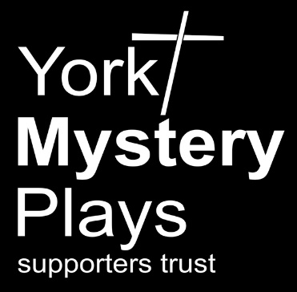
Supporter Application Form
Membership rates for 2023/24
Adults aged 18 or over - £10
Young people aged under 18 - £5
Young people living with an adult member – free

Supporters covered by this application
Name Age (if under18)
Name Age (if under18)

* Please provide any additional names overleaf
Address

Postcode

Email

We will hold your details on our database and will contact you from time to time about Supporters’ activities. If you have an email address we will usually contact you by email, if you do not have email we will contact you by post. We will not share your information with any other organisations.

Payment
£
I / we wish to become Supporters for 2023/24 at £10 / £5 per person*. Total
(* free for under 18s when an adult also joins)
£
I / we also wish to support the work of the Trust by making a donation of

☐ I have paid directly into your Co-op Bank account number: 65633564 Sort Code: 08-92-99 (Please put your name as a reference) or
☐ I have set up an annual standing order using the details above or
☐ I enclose cheque payable to York Mystery Plays Supporters Trust

Gift Aid declaration (UK members only)
I would like York Mystery Plays Supporters Trust to reclaim the tax on any eligible donations or membership fees until further notice. I confirm that I pay at least as much UK income or capital gains tax as will be reclaimed on all my Gift Aid donations in each tax year (currently 25p for every £1 you give).
Signed Date

Please return the completed form to: membership@ympst.co.uk or print and post to Membership Secretary, York Mystery Plays Supporters Trust, 14 Moor Lane, Copmanthorpe, York, YO23 3TH

